Brown Butter & Sea Salt Chocolate Chip Cookies

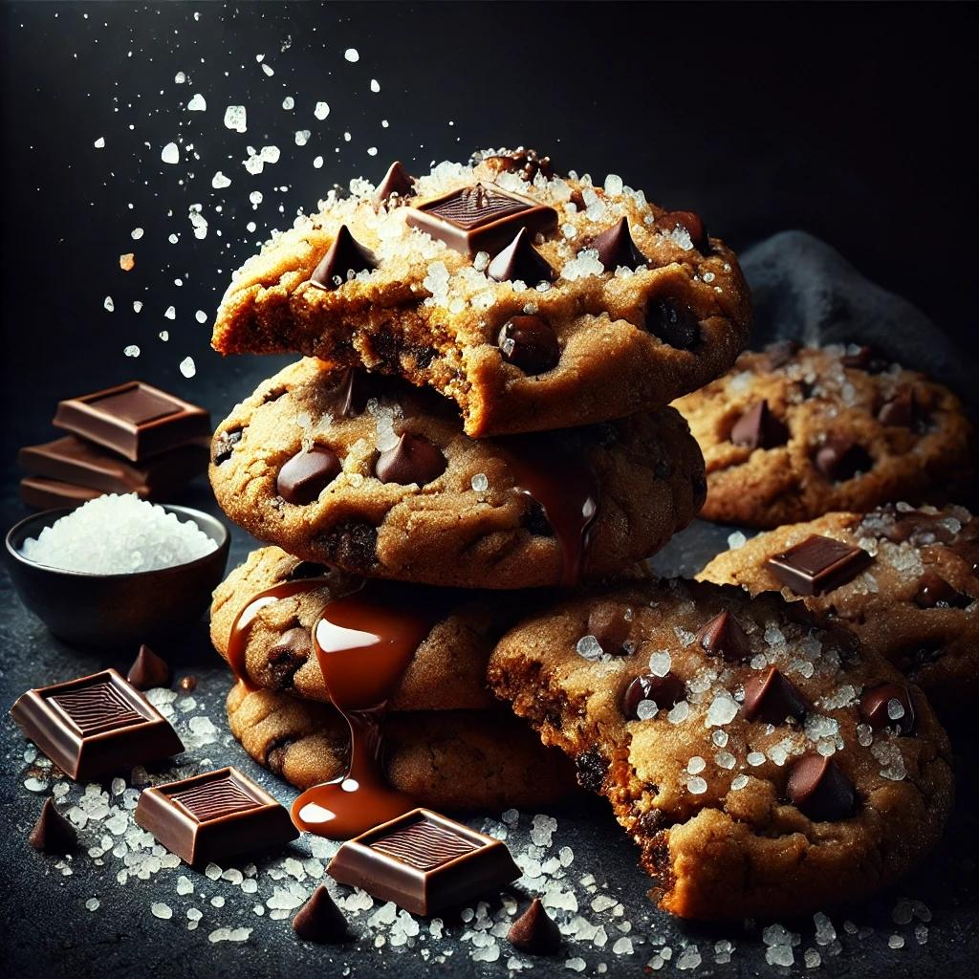

Ingredients
Brown Butter:
- 1 cup (230g) unsalted butter
Cookie Dough:
- 2¼ cups (280g) all-purpose flour
- 1 tsp baking soda
- ½ tsp salt
- 1 cup (200g) packed dark brown sugar
- ½ cup (100g) granulated sugar
- 2 large eggs
- 2 tsp pure vanilla extract
- 1½ cups (270g) semi-sweet chocolate chips or chunks
Topping:
- Flaky sea salt for sprinkling

Instructions
Step 1: Brown the Butter
- In a medium saucepan, melt the butter over medium heat.
- Stir continuously until the butter foams and turns golden brown with a nutty aroma. Remove from heat immediately to prevent burning.
- Pour the browned butter into a heatproof bowl and let it cool to room temperature.
Step 2: Mix the Dry Ingredients
- In a large bowl, whisk together the flour, baking soda, and salt. Set aside.
Step 3: Make the Dough
- In another bowl, mix the brown butter, brown sugar, and granulated sugar until well combined.
- Add eggs, one at a time, mixing well after each addition.
- Stir in vanilla extract.
- Gradually add the dry ingredients to the wet ingredients, mixing until just combined.
- Fold in the chocolate chips or chunks.
Step 4: Chill the Dough
- Cover the dough with plastic wrap and refrigerate for at least 2 hours (or overnight for deeper flavor).
Step 5: Preheat the Oven
- Preheat oven to 350°F (175°C). Line baking sheets with parchment paper.
Step 6: Scoop and Bake
- Use a cookie scoop or spoon to form 2-tablespoon-sized balls of dough.
- Place them on the prepared baking sheets, leaving enough space between cookies.
- Bake for 10-12 minutes, or until the edges are golden and the centers look slightly underdone.
- Remove from the oven and let the cookies cool on the baking sheet for 5 minutes before transferring to a wire rack.
Step 7: Sprinkle with Sea Salt
- While the cookies are still warm, sprinkle a pinch of flaky sea salt on each one.
Optional Extravagance:
- For a gourmet touch, drizzle the cooled cookies with melted dark chocolate or dip half the cookie in chocolate and sprinkle with additional sea salt.
Enjoy these decadent cookies with a perfect balance of nutty brown butter, gooey chocolate, and a hint of sea salt!

Top of Form
Bottom of Form

