Herb-Roasted Citrus Chicken
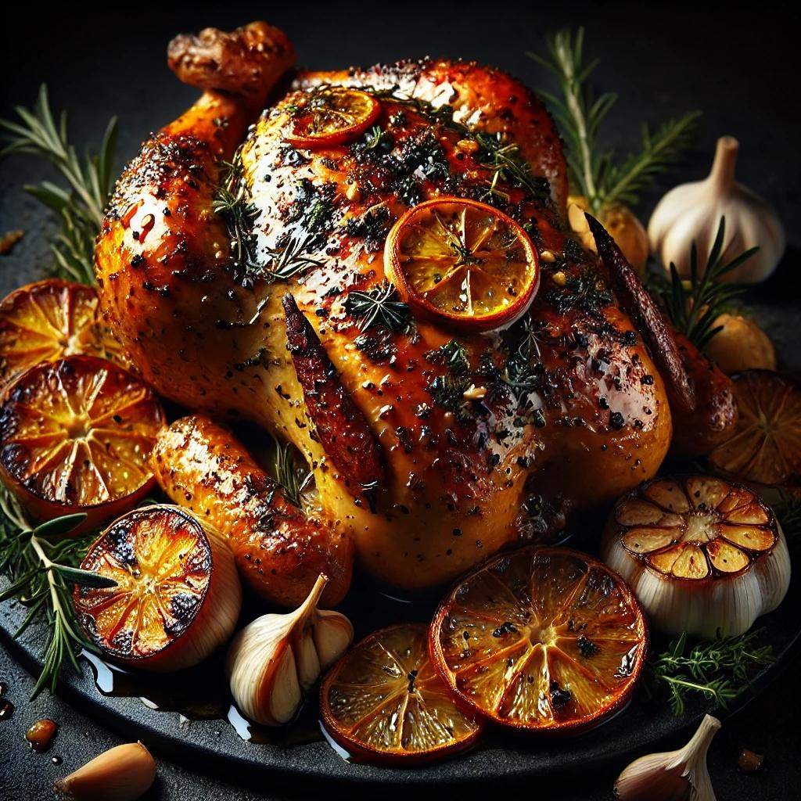

Ingredients
Chicken & Marinade:
- 1 whole chicken (4-5 lbs / 1.8-2.3 kg), giblets removed
- ¼ cup (60ml) olive oil
- 2 tbsp unsalted butter, melted
- Zest and juice of 1 orange
- Zest and juice of 1 lemon
- 3 garlic cloves, minced
- 1 tbsp Dijon mustard
- 1 tbsp honey
- 1 tbsp fresh rosemary, chopped
- 1 tbsp fresh thyme leaves
- 1 tsp fresh sage, chopped
- 1 tsp salt
- ½ tsp black pepper
- ½ tsp smoked paprika (optional)
For Roasting:
- 1 lemon, quartered
- 1 orange, quartered
- 4 garlic cloves, smashed
- 1 small onion, quartered
- 1 cup (240ml) chicken broth or white wine
Optional Garnishes:
- Fresh rosemary sprigs
- Orange and lemon slices
- Pomegranate seeds (for color)

Instructions
Step 1: Marinate the Chicken
- In a small bowl, whisk together olive oil, melted butter, citrus zest and juice, garlic, Dijon mustard, honey, chopped herbs, salt, black pepper, and smoked paprika.
- Pat the chicken dry with paper towels and rub the marinade all over, including under the skin for maximum flavor.
- Stuff the cavity with quartered lemon, orange, onion, and smashed garlic cloves.
- Cover and refrigerate for at least 1 hour (preferably overnight for deeper flavor).
Step 2: Prepare for Roasting
- Preheat your oven to 425°F (220°C).
- Place the marinated chicken in a roasting pan or a large cast-iron skillet, breast-side up.
- Pour chicken broth (or white wine) into the pan to keep the chicken moist while roasting.
Step 3: Roast the Chicken
- Roast the chicken for 20 minutes at 425°F (220°C) to achieve a golden, crispy skin.
- Reduce the oven temperature to 375°F (190°C) and continue roasting for 45-60 minutes, basting with pan juices every 15 minutes.
- The chicken is done when an instant-read thermometer inserted into the thickest part of the thigh reads 165°F (75°C).
Step 4: Rest and Serve
- Remove the chicken from the oven and let it rest for 10-15 minutes before carving to retain juices.
- Garnish with fresh rosemary sprigs, orange and lemon slices, and pomegranate seeds for a festive touch.
Serving Suggestions:
- Serve with roasted potatoes, asparagus, or a fresh citrus salad.
- Drizzle pan juices over the chicken for extra flavor.
This Herb-Roasted Citrus Chicken is fragrant, juicy, and bursting with fresh citrus and herb flavors—a perfect centerpiece for a cozy dinner or special occasion!
Bottom of Form

