Grilled Skirt Steak with Chimichurri Sauce

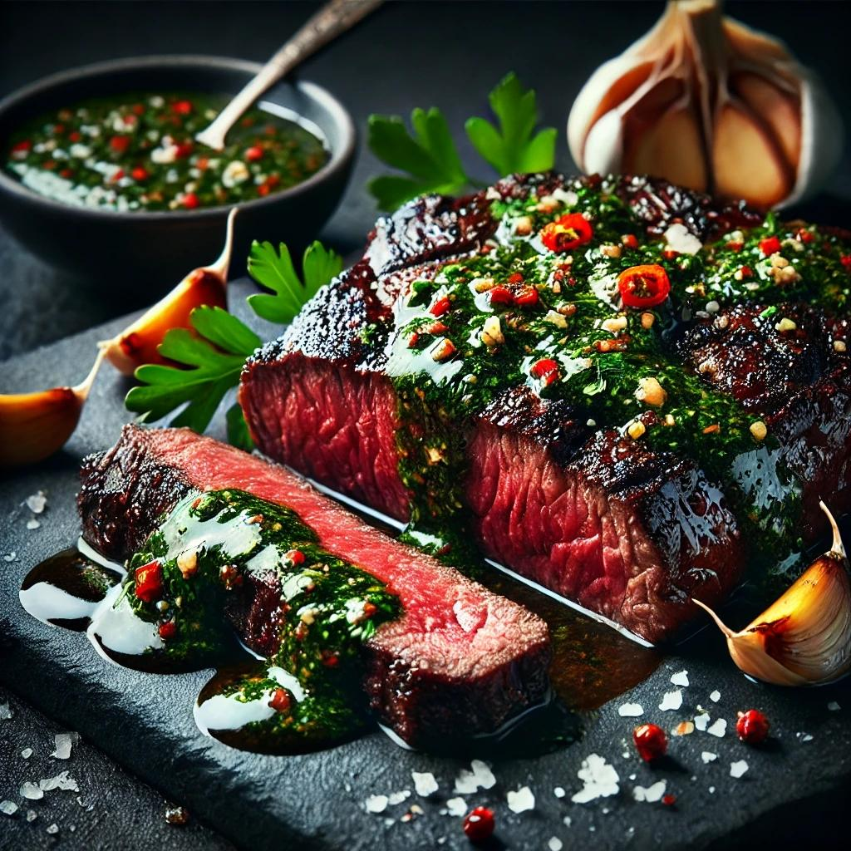

Ingredients
Steak:
- 2 lbs (900g) skirt steak, trimmed
- 3 tbsp olive oil
- 1 tsp garlic powder
- 1 tsp smoked paprika
- 1 tsp ground cumin
- 1 tsp salt
- ½ tsp black pepper
Chimichurri Sauce:
- 1 cup (30g) fresh parsley leaves, finely chopped
- ½ cup (15g) fresh cilantro leaves, finely chopped
- 3 garlic cloves, minced
- ½ tsp red pepper flakes (adjust for spice level)
- ½ tsp dried oregano
- ½ cup (120ml) olive oil
- 3 tbsp red wine vinegar
- Juice of 1 lemon
- Salt and black pepper to taste

Instructions
Step 1: Marinate the Steak
- In a small bowl, combine olive oil, garlic powder, smoked paprika, cumin, salt, and black pepper.
- Rub the mixture evenly over both sides of the skirt steak.
- Cover and let the steak marinate at room temperature for 30 minutes (or refrigerate for up to 4 hours).
Step 2: Make the Chimichurri Sauce
- In a mixing bowl, combine parsley, cilantro, garlic, red pepper flakes, and oregano.
- Stir in olive oil, red wine vinegar, and lemon juice until well combined.
- Season with salt and pepper to taste.
- Let the sauce sit for at least 15 minutes to allow the flavors to meld.
Step 3: Preheat the Grill
- Preheat your grill to high heat (around 450–500°F or 230–260°C).
- Lightly oil the grill grates to prevent sticking.
Step 4: Grill the Skirt Steak
- Place the marinated steak on the hot grill. Grill for about 3-4 minutes per side for medium-rare, or adjust cooking time based on your desired doneness.
- Remove the steak from the grill and let it rest for 5-10 minutes before slicing.
Step 5: Slice the Steak
- Slice the steak against the grain into thin strips for maximum tenderness.
Step 6: Serve with Chimichurri
- Drizzle the chimichurri sauce generously over the grilled steak.
- Serve with additional chimichurri on the side.
Optional Sides:
- Grilled vegetables (e.g., bell peppers, zucchini, or onions)
- Roasted potatoes or crusty bread
- Mixed greens or arugula salad
This Grilled Skirt Steak with Chimichurri Sauce is a bold, flavorful dish featuring tender, smoky steak and a zesty, herby sauce—a perfect pairing for summer grilling or any occasion!

