Decadent Chocolate Extravaganza Cake

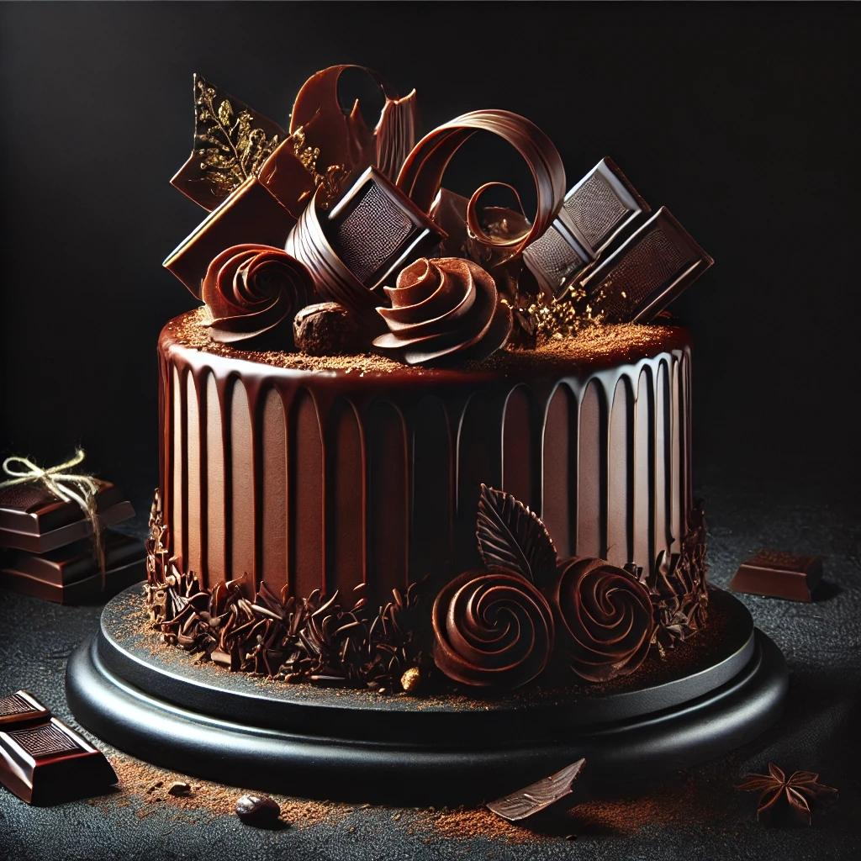

Ingredients
Cake:
- 2 cups (240g) all-purpose flour
- 1 cup (120g) unsweetened cocoa powder
- 2 tsp baking powder
- 1½ tsp baking soda
- 1 tsp salt
- 2 cups (400g) granulated sugar
- 1 cup (240ml) buttermilk
- ½ cup (120ml) vegetable oil
- 2 large eggs
- 2 tsp pure vanilla extract
- 1 cup (240ml) hot coffee
Chocolate Ganache:
- 2 cups (480ml) heavy cream
- 1½ cups (260g) dark chocolate, chopped
Chocolate Decorations:
- 200g tempered dark chocolate for curls, swirls, and shards
- Gold dust (optional)
Chocolate Buttercream:
- 1 cup (230g) unsalted butter, softened
- 4 cups (500g) powdered sugar
- ½ cup (60g) cocoa powder
- 2–4 tbsp (30–60ml) heavy cream
- 1 tsp vanilla extract

Instructions
Step 1: Make the Cake Layers
- Preheat oven to 350°F (175°C). Grease and line three 8-inch round cake pans.
- In a large bowl, sift together flour, cocoa powder, baking powder, baking soda, and salt.
- In another bowl, whisk sugar, buttermilk, oil, eggs, and vanilla. Slowly mix the dry ingredients into the wet mixture.
- Stir in hot coffee until the batter is smooth.
- Divide batter evenly among pans and bake for 30-35 minutes or until a toothpick comes out clean. Let the cakes cool completely.
Step 2: Prepare the Ganache
- Heat the cream in a saucepan until it just begins to simmer.
- Pour over the chopped chocolate and let sit for 2 minutes. Stir until smooth.
- Let the ganache cool to a spreadable consistency.
Step 3: Make the Buttercream
- Beat butter until fluffy. Add powdered sugar and cocoa powder gradually.
- Add heavy cream and vanilla. Beat until smooth and creamy.
Step 4: Assemble the Cake
- Level the cakes with a knife if needed. Spread a layer of ganache between each cake layer.
- Coat the entire cake with a thin crumb layer of ganache, then chill for 15 minutes.
Step 5: Create Chocolate Decorations
- Melt and temper the chocolate, then spread it onto a flat surface or acetate sheet.
- Make curls, swirls, and shards using a spatula or knife while chocolate is pliable.
- Dust with gold powder if desired.
Step 6: Final Decoration
- Smooth the ganache around the chilled cake for a flawless finish.
- Decorate the top with chocolate roses, shards, curls, and swirls.
- Dust with cocoa powder and gold accents for a luxurious touch.

Top of Form

Bottom of Form

