Extravagant Caramel Cheesecake

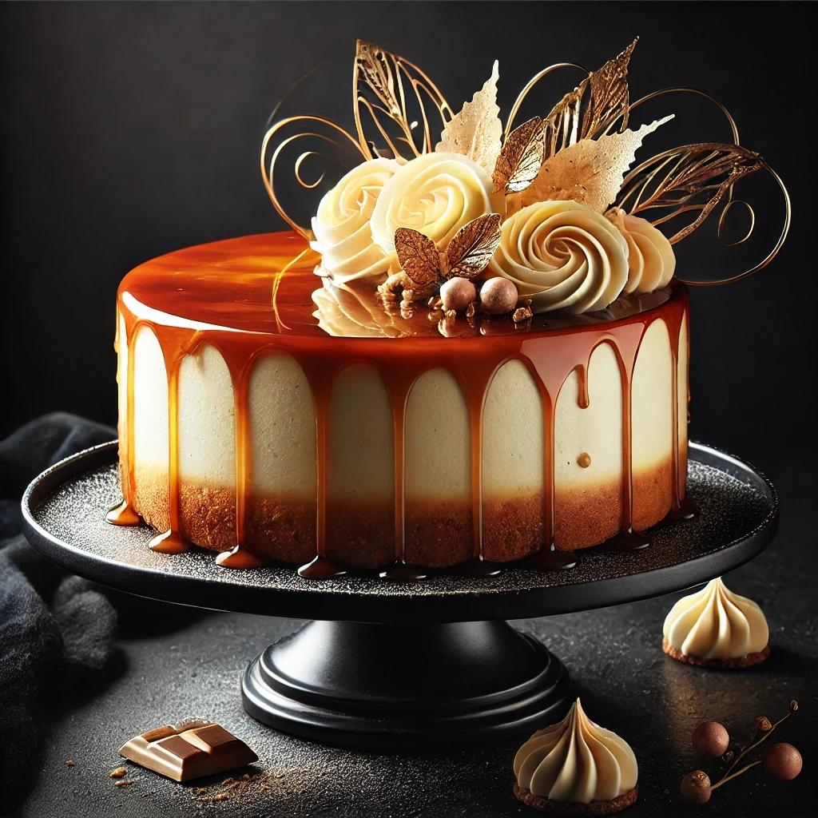

Ingredients
Crust:
- 2 cups (200g) graham cracker crumbs
- ½ cup (115g) unsalted butter, melted
- 3 tbsp granulated sugar
Cheesecake Filling:
- 3 (8 oz / 225g) packages cream cheese, softened
- 1 cup (200g) granulated sugar
- ½ cup (120ml) sour cream
- 1 tsp vanilla extract
- 3 large eggs
- 1 tbsp all-purpose flour
Caramel Sauce:
- 1 cup (200g) granulated sugar
- 6 tbsp (90ml) unsalted butter, cut into cubes
- ½ cup (120ml) heavy cream
- 1 tsp sea salt (optional)
Decorations:
- Caramel shards
- Caramel swirls or tuile
- Whipped cream
- Gold dust or edible glitter (optional)

Instructions
Step 1: Prepare the Crust
- Preheat oven to 325°F (160°C). Grease a 9-inch springform pan and wrap the bottom with foil to prepare for a water bath.
- In a bowl, mix graham cracker crumbs, melted butter, and sugar until combined.
- Press the mixture firmly into the bottom of the pan. Bake for 10 minutes, then set aside.
Step 2: Make the Cheesecake Filling
- Beat the cream cheese and sugar together on medium speed until smooth.
- Add sour cream and vanilla extract, mixing until fully combined.
- Mix in the eggs, one at a time, on low speed. Add the flour and blend until smooth.
- Pour the filling over the crust. Tap the pan gently to remove air bubbles.
Step 3: Bake the Cheesecake
- Place the springform pan in a larger roasting pan. Fill the roasting pan with hot water halfway up the sides of the cheesecake pan.
- Bake for 55-65 minutes, or until the edges are set but the center is slightly jiggly.
- Turn off the oven and leave the cheesecake inside for 1 hour with the door slightly open. Remove and let cool completely, then refrigerate for at least 4 hours (preferably overnight).
Step 4: Prepare the Caramel Sauce
- In a saucepan, melt the sugar over medium heat, stirring constantly, until it turns amber.
- Add the butter, whisking until melted. Slowly pour in the cream and stir until smooth.
- Remove from heat and stir in salt if desired. Let cool to room temperature.
Step 5: Assemble the Cheesecake
- Pour the caramel sauce over the chilled cheesecake, letting it drip slightly over the edges for an elegant effect.
- Return the cheesecake to the fridge for 20 minutes to set the caramel.
Step 6: Create Caramel Decorations
- Heat sugar in a clean saucepan until fully melted and amber-colored.
- Pour onto parchment paper or silicone mats, spreading thinly for shards or shaping into swirls while pliable.
- Dust with edible glitter or gold powder for an extravagant touch.
Step 7: Final Decoration
- Place caramel shards, swirls, or tuile on top of the cheesecake.
- Add dollops of whipped cream and drizzle more caramel sauce over the top.
- Finish with a light sprinkle of gold dust for a luxurious appearance.
Enjoy your show-stopping caramel cheesecake masterpiece!
Top of Form

Bottom of Form

