Classic Lasagna Bolognese

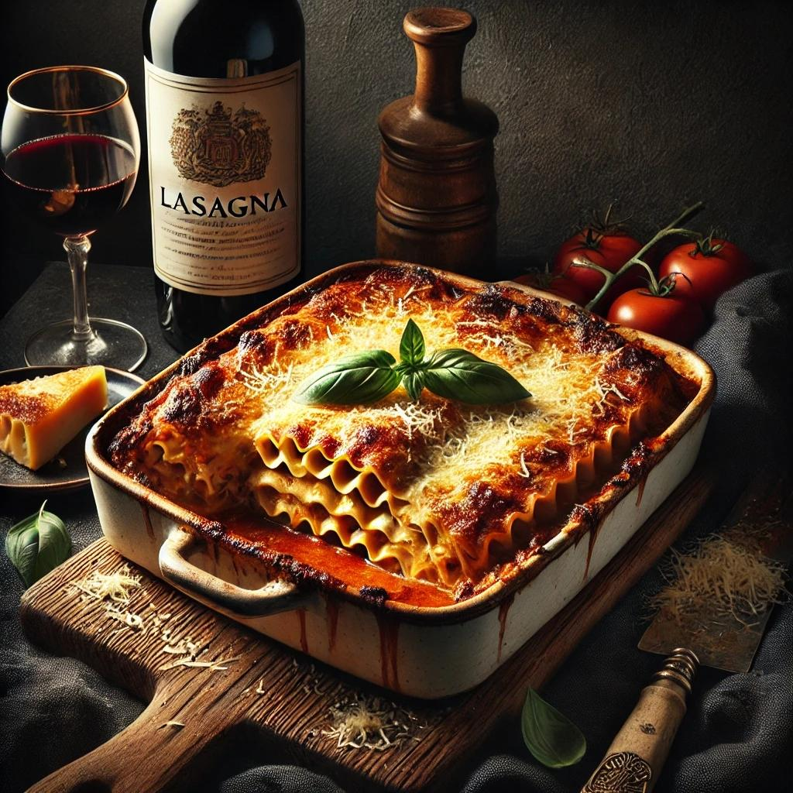

Ingredients
Bolognese Sauce:
- 2 tbsp olive oil
- 1 medium onion, finely chopped
- 2 carrots, finely chopped
- 2 celery stalks, finely chopped
- 3 garlic cloves, minced
- 1 lb (450g) ground beef
- ½ lb (225g) ground pork
- 1 cup (240ml) dry red wine
- 1 (28 oz/800g) can crushed tomatoes
- 2 tbsp tomato paste
- 1 tsp dried oregano
- 1 tsp dried basil
- Salt and black pepper to taste
- 1 cup (240ml) whole milk
Béchamel Sauce:
- 4 tbsp (60g) unsalted butter
- 4 tbsp (30g) all-purpose flour
- 3 cups (720ml) whole milk, warmed
- ¼ tsp ground nutmeg
- Salt and black pepper to taste
Lasagna:
- 12 lasagna noodles (no-boil or cooked)
- 2 cups (200g) shredded mozzarella cheese
- 1 cup (100g) grated Parmesan cheese
- 1 cup (200g) ricotta cheese (optional)
- Fresh basil leaves for garnish (optional)

Instructions
Step 1: Make the Bolognese Sauce
- Heat olive oil in a large pot over medium heat. Add onions, carrots, and celery, and sauté until softened (about 5 minutes).
- Add garlic and cook for 1 minute. Stir in ground beef and pork, breaking it apart with a spoon. Cook until browned.
- Pour in red wine and simmer until mostly evaporated (about 5 minutes).
- Stir in crushed tomatoes, tomato paste, oregano, and basil. Season with salt and pepper.
- Reduce heat to low and simmer for 1½–2 hours, stirring occasionally. Add milk during the last 30 minutes of cooking for a creamy finish.
Step 2: Make the Béchamel Sauce
- In a medium saucepan, melt butter over medium heat. Stir in flour and cook for 1-2 minutes to form a roux.
- Gradually whisk in warm milk until smooth. Cook, stirring constantly, until thickened (about 5 minutes).
- Season with nutmeg, salt, and pepper. Remove from heat and set aside.
Step 3: Prepare the Lasagna Noodles
- If using traditional lasagna noodles, cook according to package instructions. Drain and lay flat on a parchment-lined tray to prevent sticking.
Step 4: Assemble the Lasagna
- Preheat oven to 375°F (190°C).
- Spread a thin layer of Bolognese sauce on the bottom of a 9x13-inch baking dish.
- Add a layer of lasagna noodles, followed by Bolognese sauce, a drizzle of béchamel sauce, and a sprinkle of mozzarella and Parmesan cheese.
- Repeat layers until all ingredients are used, ending with a generous layer of béchamel and cheese on top.
Step 5: Bake
- Cover the lasagna with foil (avoid touching the cheese) and bake for 25 minutes.
- Remove the foil and bake for an additional 15-20 minutes until the top is golden and bubbly.
Step 6: Rest and Serve
- Let the lasagna cool for 10-15 minutes before slicing to allow it to set.
- Garnish with fresh basil leaves, if desired, and serve with a side salad or garlic bread.
This Lasagna Bolognese is a hearty, comforting dish with layers of rich meat sauce, creamy béchamel, and melted cheese—perfect for family dinners or special occasions!

Top of Form
Bottom of Form

