Rum-Soaked Banana Bread

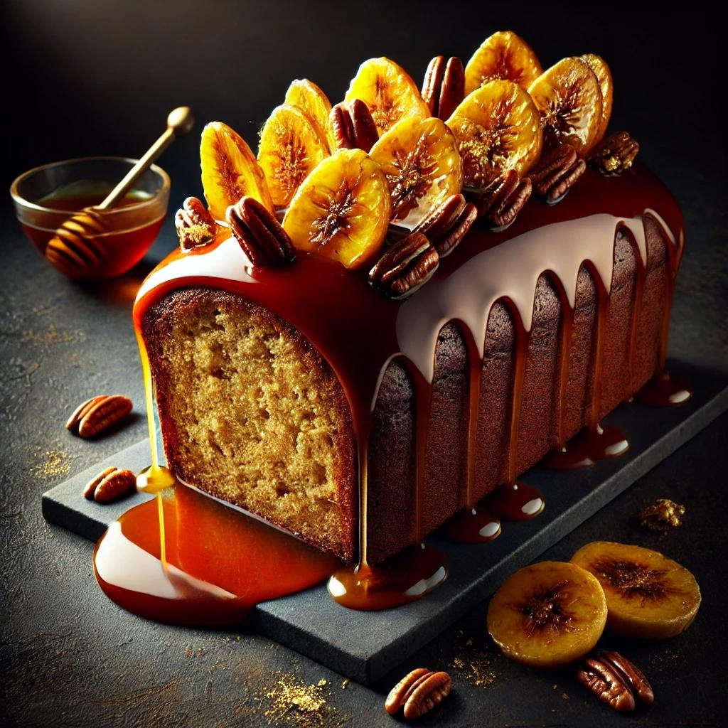

Ingredients
Banana Bread:
- 2 cups (250g) all-purpose flour
- 1 tsp baking soda
- ½ tsp baking powder
- ½ tsp salt
- ½ tsp cinnamon (optional)
- ½ cup (115g) unsalted butter, softened
- 1 cup (200g) granulated sugar
- 2 large eggs
- 1 tsp vanilla extract
- ½ cup (120ml) dark rum
- 3 ripe bananas, mashed
- ½ cup (120ml) buttermilk (or whole milk with 1 tsp vinegar/lemon juice)
Rum Syrup:
- ¼ cup (50g) granulated sugar
- ¼ cup (60ml) dark rum
- 2 tbsp water
- 1 tbsp unsalted butter
Optional Toppings:
- Toasted nuts (pecans or walnuts)
- Sliced bananas
- Powdered sugar for dusting

Instructions
Step 1: Preheat and Prepare
- Preheat your oven to 350°F (175°C). Grease a 9x5-inch loaf pan and line it with parchment paper.
Step 2: Mix the Dry Ingredients
- In a bowl, whisk together the flour, baking soda, baking powder, salt, and cinnamon (if using). Set aside.
Step 3: Make the Batter
- In a large bowl, cream the softened butter and sugar until light and fluffy.
- Add the eggs, one at a time, mixing well after each addition. Stir in the vanilla extract and rum.
- Mix in the mashed bananas until combined.
- Alternate adding the dry ingredients and buttermilk to the wet mixture, beginning and ending with the dry ingredients. Mix until just combined (do not overmix).
Step 4: Bake
- Pour the batter into the prepared loaf pan and smooth the top.
- Bake for 50-60 minutes, or until a toothpick inserted into the center comes out clean.
- Let the bread cool in the pan for 10 minutes before transferring to a wire rack.
Step 5: Prepare the Rum Syrup
- In a small saucepan, combine sugar, rum, water, and butter. Heat over medium heat until the sugar dissolves and the mixture begins to simmer. Cook for 1-2 minutes, then remove from heat.
Step 6: Soak the Banana Bread
- Using a skewer or toothpick, poke small holes all over the warm banana bread.
- Brush or spoon the warm rum syrup over the bread, allowing it to seep into the holes. Repeat until the syrup is used up.
- Let the bread sit for 30 minutes to absorb the syrup completely.
Step 7: Add Final Touches
- Optional: Top with toasted nuts, sliced bananas, or a light dusting of powdered sugar.
- Slice and serve the rum-soaked banana bread as is, or with a dollop of whipped cream for an extra treat.
This moist, flavorful banana bread with a rich rum infusion is perfect for special occasions or when you want to elevate a classic dessert!
4o
Top of Form

Bottom of Form

